 | SCT Forward Power Tape from PPF0 to Module
ATLAS Project Document No: | Institute Document No. | Created: 02/08/02 | Page: 1 of 12
ATL-IS-ES-0034 | GLAPT02/002 | Modified :24/03/03 | Rev. No.: B

DRAFT
SCT Forward Power Tape from PPF0 to Module

Abstract
This report documents the design, assembly procedure, and specification of the forward SCT power tape from PPF0 to each module on the disc.

Prepared by:  Val O'Shea | Checked by:  Deborah Greenfield | Approved by:
Distribution List

History of Changes
Rev. No. | Date | Pages | Description of changes
B | 28/03/03 | All | Reflects changes in the tape design to incorporate the patch panel itself onto the tape. The new layout has been made more robust and incorporates the latest additions to make it compatible with a comprehensive grounding and shielding strategy for the detector system. Following a review of the performance requirements, the tapes now utilise double sided copper on kapton with through plated holes for the control signals and copper clad aluminium twisted pairs to carry the power to the modules.

Table of Contents
1. Introduction 4
2. Associated Documents 5
3. Power Tapes 5
1.1 Kapton Pinout 6
1.2 Kapton Specification 6
1.3 CCA Twisted Pair Assembly 8
1.4 Powertape Assembly 9
4. Powertape Routing and Distribution 10
5. Tape Radiation Length 11
6. Test 12
7. References 12

Introduction

The powertapes are intended to carry the power supply currents and DC levels from PPF0 at the periphery of the disk to each detector module. In order to minimise the radiation length of the cable the high current lines are carried on Copper Clad Aluminium (CCA) twisted pairs while the low current/static lines are implemented on a classic copper kapton, which carries the connectors and permits through plated holes for optimal routing. The use of twisted pairs maximises the ratio of material available to carry the current to the modules as a fraction of the total material used. The use of a copper clad solution removes the uncertainty associated with soldering to aluminium.
Because of the reduction in unit tape width, a more flexible routing strategy over the disk surface is possible which results in a reduction in the total length of tape required to supply all the modules. The reduction in radiation length of the tapes has to be traded off against the electrical resistance of the power supply lines as the voltage drop along the total cable length is at the limit of that which can be compensated for by the power supplies.

- The new layout of the tape includes a direct connector-to-connector solution to the incoming low mass tape from PPF1 rather than via a PCB thereby minimising the material that is needed for the patch panel construction.

- Pads have been added at both the module and PPF0 ends of the tapes so that that the required grounding connections can be made.

The use of standard design rules for PCB manufacture gives a unit tape width of 3.6 mm per module (including the IPC2221 recommended minimum separation for the high voltage lines) which results in a tape layout without any overlapping or crossovers along the tape paths.

- The powertapes will provide an individual supply to each module on the disc from the patch panel at PPF0 with minimal radiation length and voltage drop.

- Provide a robust soldered connectorised solution at both ends of the tape in order to optimise the disc assembly and repair processes.

  - Permit the appropriate connection of grounding and shielding for optimum detector performance.

Associated Documents

This section lists the documents and drawings associated with this report:

Document No. | Type | Title
TD-1010-182 | Assembly Drawing
TD-1010-345 | Ref. Drawing | Patch Panel and connections
TD-1010-349 | Ref. Drawing | Opto Bracket
TD-1002-947 | Part Drawing | Tape W1 Discs 2,3,4,5,6
TD-1002-945 | Part Drawing | Tape W2 Discs 1-9
TD-1002-948 | Part Drawing | Tape W3 Discs 1-9
TD-1002-949 | Part Drawing | Tape W4 Discs 2-6
TD-1002-942 | Part Drawing | Tape W5 Discs 2-6
TD-1002-941 | Part Drawing | Tape W6 Discs 2-6
TD-1002-938 | Part Drawing | Tape W7 Discs 1-8
TD-1002-966 | Part Drawing | Tape W8 Discs 2-6
TD-1002-970 | Part Drawing | Tape W9 Discs 2-6
TD-1002-971 | Part Drawing | Tape W10 Discs 2-6
TD-1002-967 | Part Drawing | Tape W11 Discs 2-6
TD-1002-974 | Part Drawing | Tape W12 Discs 2-6
TD-1040-345 | Ref. Drawing | Short Patch Panel
TD-1040-349 | Ref. Drawing | Opto Bracket
TD-1040-947 | Part Drawing | Tape W1 Discs 1,7,8,9
TD-1040-949 | Part Drawing | Tape W4 Discs 1,7,8,9
TD-1040-942 | Part Drawing | Tape W5 Discs 1,7,8,9
TD-1040-941 | Part Drawing | Tape W6 Discs 1,7,8,9
TD-1040-966 | Part Drawing | Tape W8 Discs 1,7,8,9
TD-1040-970 | Part Drawing | Tape W9 Discs 1,7,8,9
TD-1040-910 | Part Drawing | Tape W10 Discs 1,7,8,9
TD-1040-967 | Part Drawing | Tape W11 Discs 1,7,8,9
TD-1040-974 | Part Drawing | Tape W12 Discs 1,7,8,9

Power Tapes
The final powertape assembly is constructed with wires and kapton circuits in order to maximise the conductor cross section available for current transport to the module and minimise the voltage drop along the tape. This is a critical design parameter of the tape as the voltage drop along the total tape length is already at the limit of that which can be compensated for by the power supply units.

Kapton Pinout

Hybrid End Samtec P/N FTM-114-03-L-DV PPF0 End Samtec P/N CLP-115-02-L-DV

1. no pin 2. no pin
3. ILED 4. ILED 1. SPARE 2. ILED
5. PINBIAS 6. SELECT 3. PINBIAS 4. SELECT
7. TEMP 8. RESET 5. TEMP 6. RESET
9. DGND 10. VDD 7. DGND 8. VDD
11. DGND 12. VDD 9. DGND 10. VDD
13. DGNDS 14. VDDS 11. DGND 12. VDD
15. AGNDS 16. VCCS 13. DGNDS 14. VDDS
17. AGND 18. VCC 15. AGNDS 16. VCCS
19. AGND 20. VCC 17. AGND 18. VCC
21. BIASRET 22. no pin 19. AGND 20. VCC
23. no pin 24. no pin 21. AGND 22. VCC
25. no pin 26. no pin 23. no pin 24. BIASRET
27. N/C 28. HVBIAS 25. no pin 26. no pin
27. no pin 28. no pin
29. no pin 30. BIAS

The pins 20 through to 25 have been removed on the module connector in order to respect the HV clearance required as the pin pitch is too small. Pins 27 and 28 have also been removed to create an overhang on the connector body. This will afford some purchase for a tool to remove the connector without placing strain on the kapton tape. The pin pitch change on the Samtec connector from metric to imperial is realised at PPF0 and is necessary in order to maintain the specified clearance on a 1.27 mm pitch connector where the connections are exposed. Pins 25 to 28 will be removed on the PPF0 connector.

Kapton Specification
The individual kapton tapes are made from double sided 0.5 oz. copper (18 μm thick) on 100 μm kapton tape. The traces are laid out with 150 μm track and 125 μm space (6/5 thou) with a 0.8 mm separation for the high voltage trace. The traces are then capped with a 50 μm photoimageable kapton layer on each side on which the apertures for component assembly are then opened. These layers provide the required isolation to permit the reduction in trace separation from 2.5 to 0.8 mm (IPC 2221) for covered traces with large voltages between them. Where the trace is exposed the nearest uncovered conductor is no closer than 2.5 mm to it.
The shapes and layout of the individual tapes have been defined by extraction from a 3-D model built up in ProEngineer and flattened to 2-D shapes that can be used to generate the files needed to generate a layout. These drawings are listed in the preceding section as tape outline drawings.

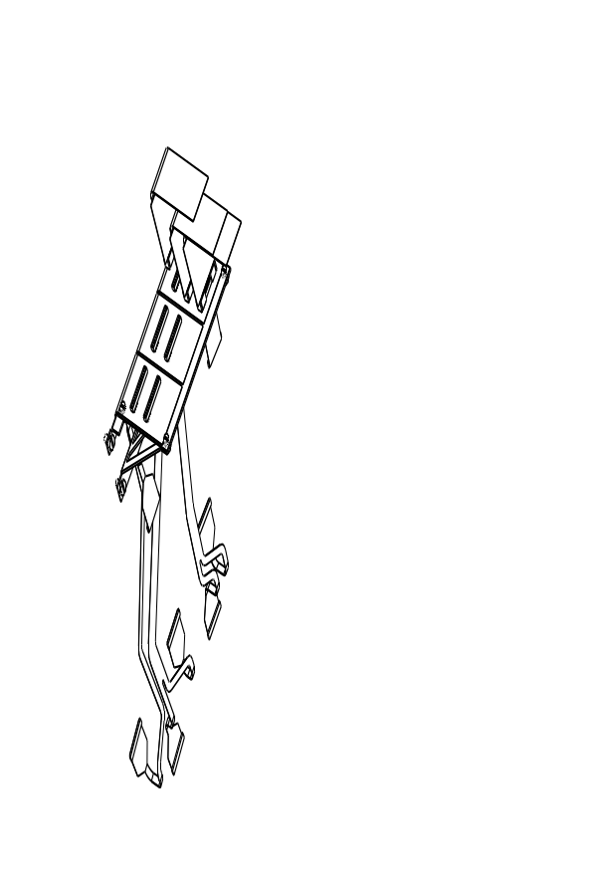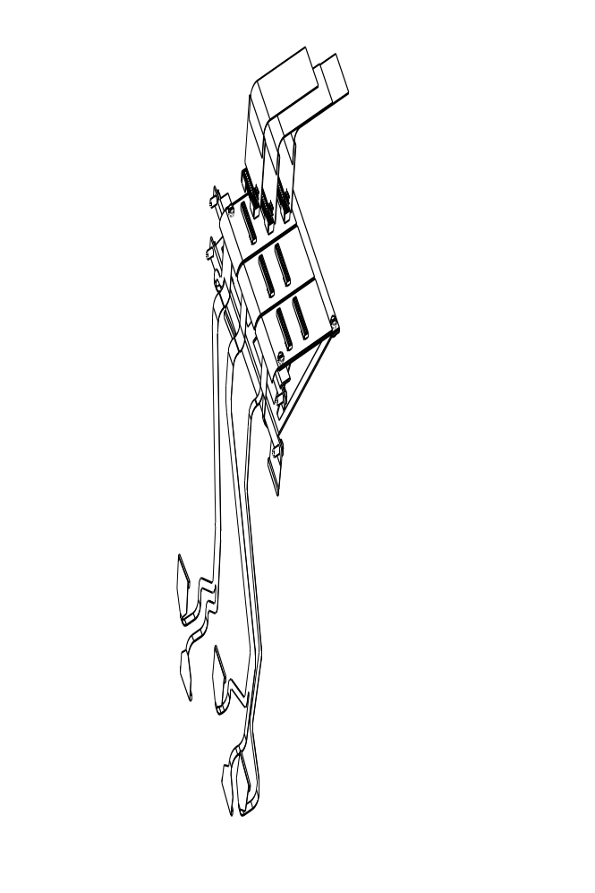

Fig.1 shows the physical 3-D representation of a single patch panel complete with the incoming tapes and termination board from two angles. The rightmost tape serves three modules while the other two tapes serve two modules each. Modules on both sides of the disk may be served by a single tape as the double sided technology used means that different connector orientations and mountings may be used. (Detail is preserved at full zoom.)
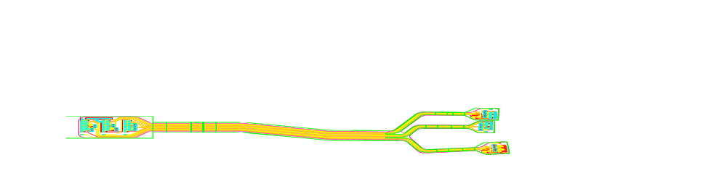


Fig.2 The PPF0 and module connections for the tapes give rise to five variants for the tape ends .The three types of PPF0 reflect the number and position of the modules served by any particular tape while the two types of module connection are dictated by the different connector orientation of the inner modules with respect to the outer and middle modules. (Detail is preserved at full zoom.)

Fig.3 The cross section of the assembled tape is outlined in the above drawing to give a tape unit width of 3.6 mm for the most part of the tape length.

0.8 mm

CCA twisted pair
Bias and return

3.6 mm unit tape width
0.8/1.4 mm tape heightSense 1&2
Sense 3&4
Temp&Reset
150 μm lines / 150 μm spacesPinb&SelIled 1&2

CCA Twisted Pair Assembly

The cable assembly makes use of a special build of wire developed for the magnet industry which uses an Aluminium core clad with a Copper skin. This wire is then insulated with a colour coded polyimide/nylon insulating coating and wound as a twisted pair. The wire is readily solderable using the standard soldering techniques and avoids the difficulties associated with the soldering of Aluminium while offering a considerable reduction in the radiation length of the assembly for a marginal increase in the resistance of the power conductors.

Typical Physical Properties
A.C. conductivity > 5 MHz....Equal to solid copper
D.C. conductivity....65% IACS
Density....1199 lbs / cubic inch
% copper by volume....10% + 2%
% copper by weight....26.8% + 2%
Coefficient of thermal expansion....22.9 ppm / °C
Tensile strength - Annealed....16,500 psi
Tensile strength - Hard....23,5000 psi
Yield strength - Annealed....12,000 psi
Yield strength - Hard....21,6000 psi
% elongation - Annealed....15%
% elongation - Hard....2.5%

Table1: The preceding table indicates the typical properties of the Copper Clad Aluminium (CCA) wire.(Courtesy MWS Wire Industries)

The twisted pair maintains its full cross-section up to the connector ensuring that there are no additional voltage drops due to the tape layout. The pair consists of 2X23 AWG strands of CCA which is specified to have a resistance of 16 mΩ per pair per foot. This translates to 105 mΩ/m per conductor which is within the specified requirements for the powertapes. The voltage drop at the specified current⁽¹⁾ of 1.3 Amperes is 0.143 volt/metre of tapelength. The twisted pair will comprise of green and red poly/nylon coated 0.55 mm CCA wires with a nominal twist of 2 TPI.
Because of the need to relax the twists on the wires as they pass under each cooling pipe, each section of wire needs to be carefully prepared prior to soldering to its respective tape. This preparation will involve preforming the wire, relaxing the twists at the appropriate points where the pair passes under the cooling pipe and tinning the ends. The passage of the cooling pipe has been extracted from the master drawing and incorporated in the silk screen markings for each tape. The wire pairs will be taped flat to the kapton using lengths of adhesive kapton folded around the tape.

Powertape Assembly

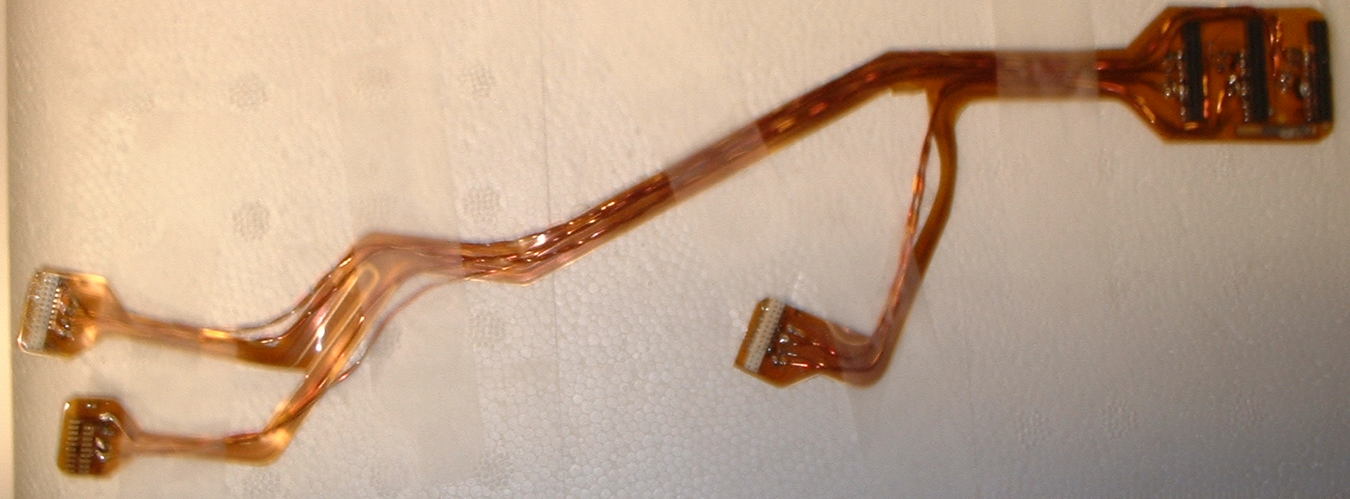

Fig.4. A schematic representation of the addition of the 2 twisted pairs per module to a tape. In reality the assembly is as shown in the photograph above.

The connectors used for the kapton are the SAMTEC P/N CLP-115-02-L-DV for the PPF0 side and the Samtec P/N FTM-114-03-L-DV for the connection to the module. These connectors are re-flow soldered to the kaptons using standard assembly techniques.
The two sets of tinned, formed and cleaned twisted pairs are then soldered to their respective pads on the kapton tape for each module and the entire assembly is then cleaned in order to remove the flux residues.
Each PPF0 end of the tape will be rigidised with a thin shim of FR4 cut to the shape of the tape outline and laminated to the kapton using Dupont LG-1000. Protection of the tape assembly at the module end will be achieved by encapsulation with epoxy.
An additional finger is to be soldered to each module end of the tape prior to potting as there is a need to make a connection between the Analogue Ground on the powertape and the cooling. The connection will be made via this finger from the digital ground on the tape/module to a ring that fits around the module pin on the cooling block. As the module nut is tightened a good electrical connection is established.

Powertape Routing and Distribution
The powertapes are gouped into sets of three tapes as indicated in Fig.1. These are mounted on four patch panels for each quadrant. The tapes then occupy one of twelve positions on any given quadrant of a disc. These are designated W1 to W12 starting from noon and proceeding clockwise while looking at the front of the disc (looking from the interaction point).
The layout of the tapes has been further complicated by the need to place the discs as close as possible to each other. On the discs where there are no inner modules (1,7,8,9) the tapes can be made so that there are never more than two modules per tape – this results in a shorter PPF0 thereby helping to reduce the disc seperation. This, however, leads to more variants per tape as the missing inner modules have not always been routed to the same connector on PPF0 in order to minimise the tape length. Three tapes, W2, W3 and W7 serve only two modules and so may also be used on the ‘short’ discs. This gives rise to a total number of tape variants of 21 (12+9).

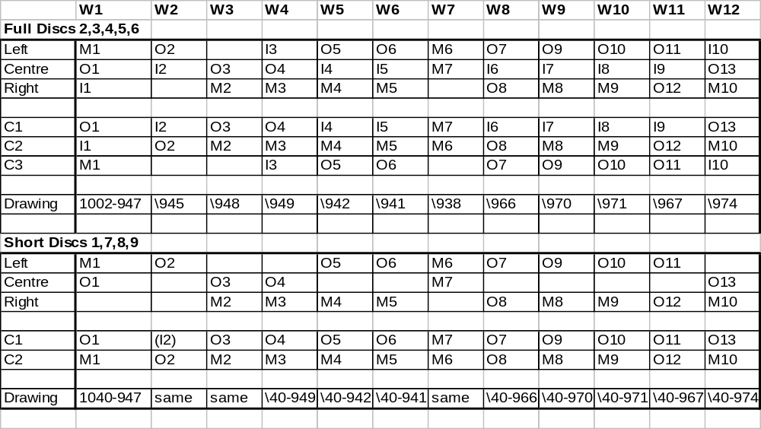

Table 2. The assignment of modules to tapes and the respective position within each quadrant for connection to the low mass tapes from PPF1. The designations Mx, Ox, Ix refer to modules of types Outer, Inner and Middle, C to connectors on each tape at PPF0 with C1 nearest to the disc when on it’s patch panel support.

Tape Radiation Length
The use of Copper kapton circuit allied to Copper Clad Aluminium to carry the power to the modules has resulted in the optimised distribution of material between the signal and power lines on the powertape assembly while using a viable technology for the production of the tapes.
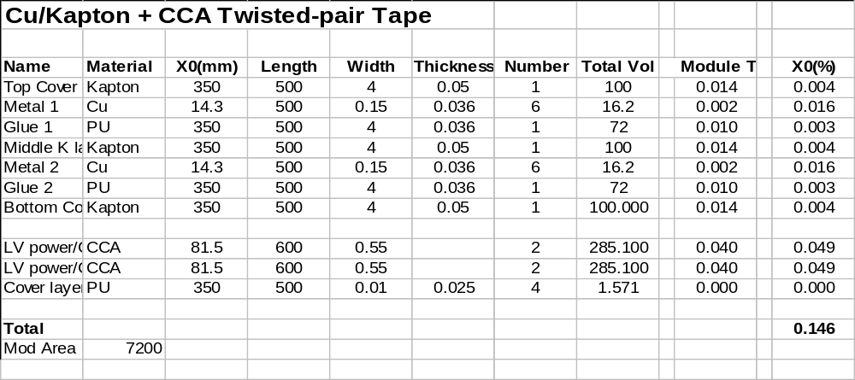
Table 3. The calculation of the radiation length contribution from each of the components to the total radiation length averaged over the area of an outer module. The wire used is the 23 AWG CCA with 10% Cu by volume. This is to be compared with a value of 0.16 for the originally proposed tape which had no integrated patch panel.

Test

The low mass tapes are tested for:

- connector to connector resistance (for continuity and nominal resistivity)
- interline resistance (detection of short-circuits between signal and power lines)
- leakage current from the high voltage bias; tested to 500V

The test is performed on a custom fixture and is controlled by dedicated software which performs automatic measurements and stores them directly to both the low mass tape database and file. This fixture, the dummy hybrid that goes on the module end of the hybrid and the test setup and software have been already developed for the testing of the SCT Barrel harnesses which have a similar electrical configuration. It is intended to copy the setup currently in use at Rutherford Appleton Laboratories⁽²⁾ for this purpose.

References
  - http://www-f9.ijs.si/~mm/lm_spec.html
  - Rutherford Cable test specification (to be supplied)

